Process & Decision Documentation

Side Quests and A4 (Individual Work)
- Created multi-sensory effects for side quest example 2.
- I added a sound effect when the fox lands from a jump.
- For visual effect, I added disappearing dusts when the fox lands from a jump.

Role-Based Process Evidence
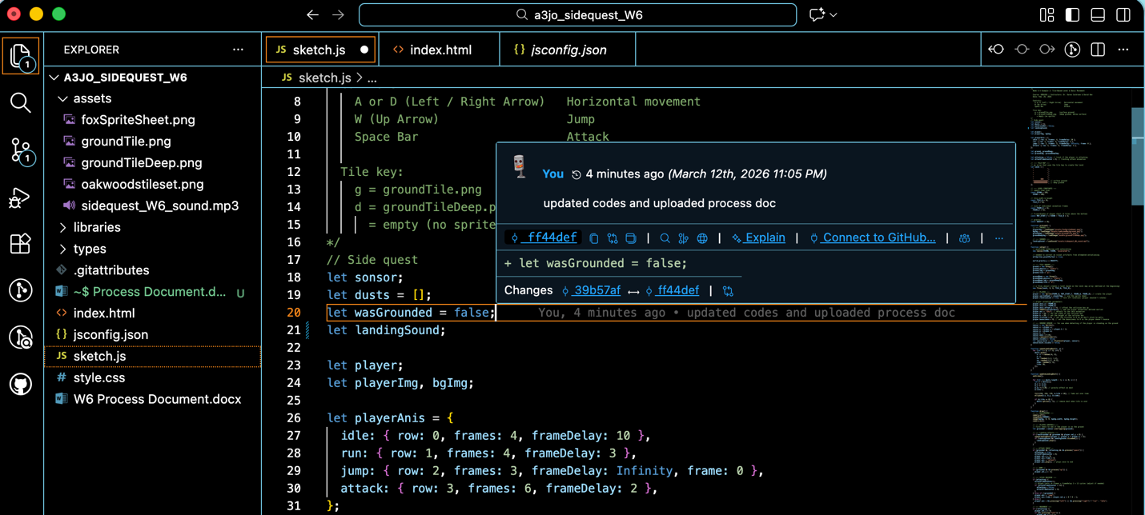
Writing code on VSC
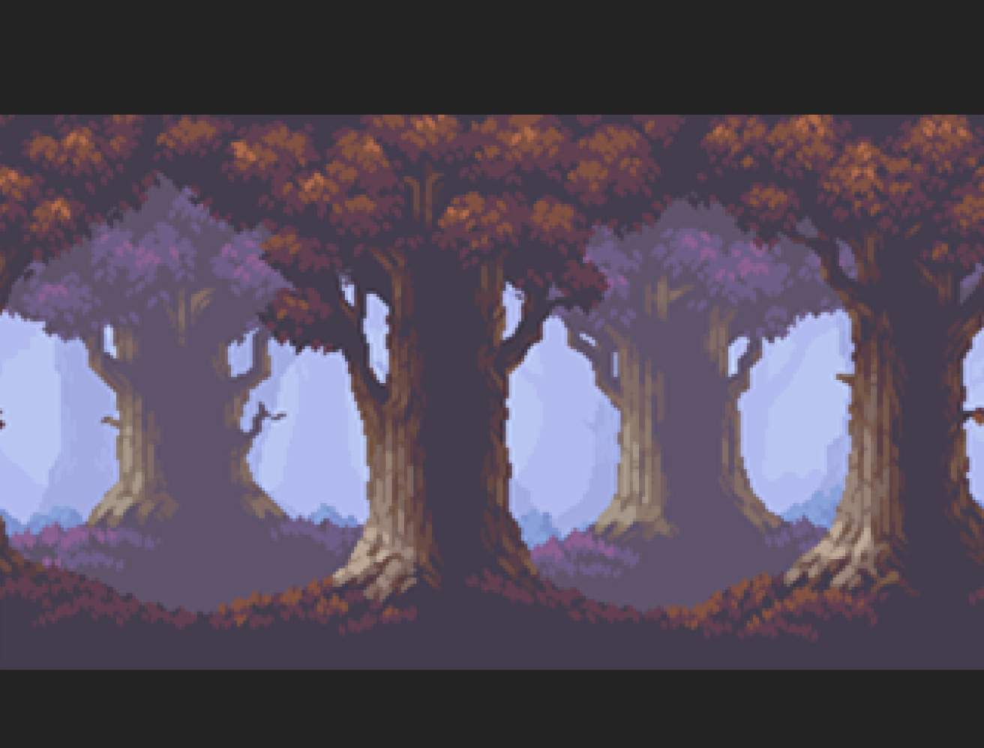
Failure in implementing new effect which made the fox and ground disappear when I attempted to make the fox jump.
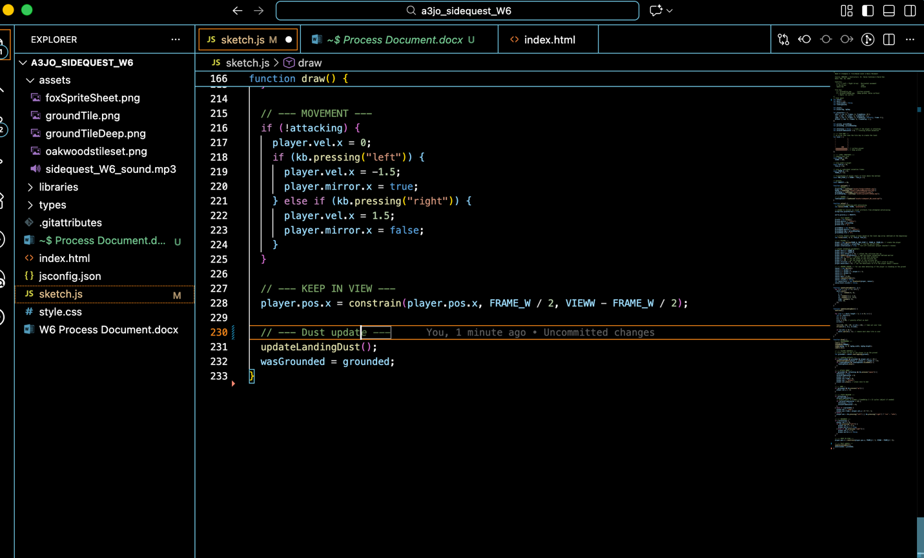
Writing comments

GenAI Documentation

If GenAI was used (keep each response as brief as possible):
Date Used: March 12, 2026
Tool Disclosure: ChatGPT 5.2
Purpose of Use: Making my ideas into codes and debugging errors.
Summary of Interaction: From my ideas of making the visual and audio effects, GenAI helped to make those ideas into codes and suggested where to include the new codes in the original js so that I’m adding my codes on top without changing the existing design.
Human Decision Point(s): I didn’t give them my files so GenAI had to rely on my instructions in making the visual effects. So there were a few redirections in the effect design due to lack of coding context.
Integrity & Verification Note: Made iterations based on my decisions without giving all authority or sources to GenAI. Checked the correctness throughout the process by testing the game in every code adoption.
Scope of GenAI Use: GenAI did not contribute to ideation of the effects. I chose and downloaded the audio effect on my own and instructed the visual effect’s mechanics to GenAI.
Limitations or Misfires: There was limitations in communicating with GenAI because it doesn’t have the access to my files and cannot see the gameplay, it had a few misunderstandings in implementing the new effects.

Appendix
Me:
I’m adding a simple visual and audio effects to a sketch of a simple game where the fox moves according to the user’s arrow control. For the visual effect, help me make a landing dust effect. It triggers when the fox lands after a jump and it should fade out over time. Make tiny dust pixel puffs near the tail of the fox. Also I’m adding a sound effect to tell me how I should load the sound effect.

ChatGPT:
Yes — here’s a simple way to add a landing dust effect and a landing sound to your current fox game structure.

Add new variables at the top
let sensor;
let dusts = [];
let wasGrounded = false;
let landSfx; // sound that plays when fox lands

Load the sound in preload()
function preload() {
landSfx = loadSound("assets/land.wav");
}
Use your own file name if needed, like:
- assets/land.mp3
- assets/jumpLand.wav
Also make sure the p5.sound library is included in your project, or loadSound() will not work.

Add the dust helper functions
Put these below setup() and above draw(), or below draw() if you prefer.
function spawnLandingDust(x, y) {
for (let i = 0; i < 6; i++) {
dusts.push({
x: x + random(-6, 6),
y: y,
vx: random(-1.2, 1.2),
vy: random(-1.5, -0.2),
size: random(3, 6),
life: 20
});
}
}
function updateAndDrawDust() {
noStroke();
for (let i = dusts.length - 1; i >= 0; i--) {
let d = dusts[i];
d.x += d.vx;
d.y += d.vy;
d.vy += 0.05;
d.life--;
fill(230, 210, 170, d.life * 10);
ellipse(d.x, d.y, d.size);
if (d.life <= 0) {
dusts.splice(i, 1);
}
}
}

Trigger the dust + sound when the fox lands
Inside draw(), add this landing check:

let grounded = sensor.overlapping(ground);
// --- LANDING EFFECT ---
if (!wasGrounded && grounded && player.vel.y >= 0) {
spawnLandingDust(player.x, player.y + player.h / 2);
if (landSfx && !landSfx.isPlaying()) {
landSfx.play();
}
}
Then near the end of draw(), update the dust and save the grounded state:
updateAndDrawDust();
wasGrounded = grounded;

Important note about browser audio
Sometimes sound will not play until the user interacts with the page first. If that happens, add this to setup():

function keyPressed() {
userStartAudio();
}

Me:
I implemented the codes but it makes the fox and ground disappear when the fox jumps and it doesn’t have a sound either. Suggest me solutions.
ChatGPT:
That usually happens because one of these broke the sketch:
- dusts / wasGrounded / landSfx was not declared at the top
- loadSound() is being used without the p5.sound library
- the landing code was inserted in the wrong spot
Use this safer version.

1. Add these globals at the top
Put them near your other let variables:
let sensor;
let dusts = [];
let wasGrounded = false;
let landSfx;

Update preload()
Important: this only works if your HTML includes the p5.sound library.
Example:
<script src="https://cdn.jsdelivr.net/npm/p5@1/lib/addons/p5.sound.min.js"></script>
Without that, loadSound() will fail and no sound will play.

Turn on browser audio after interaction
Add this anywhere below your functions:
function mousePressed() {
userStartAudio();
}
function keyPressed() {
userStartAudio();
}
Some browsers block sound until the user clicks or presses a key once.

Why your fox/ground probably disappeared
The most likely reason is that one of the new variables or sound functions caused a runtime error, so the sketch stopped updating correctly. The most common one is:
landSfx = loadSound(...)
without loading p5.sound.min.js.
Another common issue is forgetting:
let dusts = [];
let wasGrounded = false;
let landSfx;
at the top.

Quick checklist
Make sure all 4 are true:
- let dusts = []; exists
- let wasGrounded = false; exists
- let landSfx; exists
- p5.sound.min.js is included in your HTML

